INTERNATIONAL PEACE BUREAU

A CLIMATE OF PEACE
NOBEL-CENTENARY CONFERENCE:
OSLO, 23-26 SEPTEMBER 2010

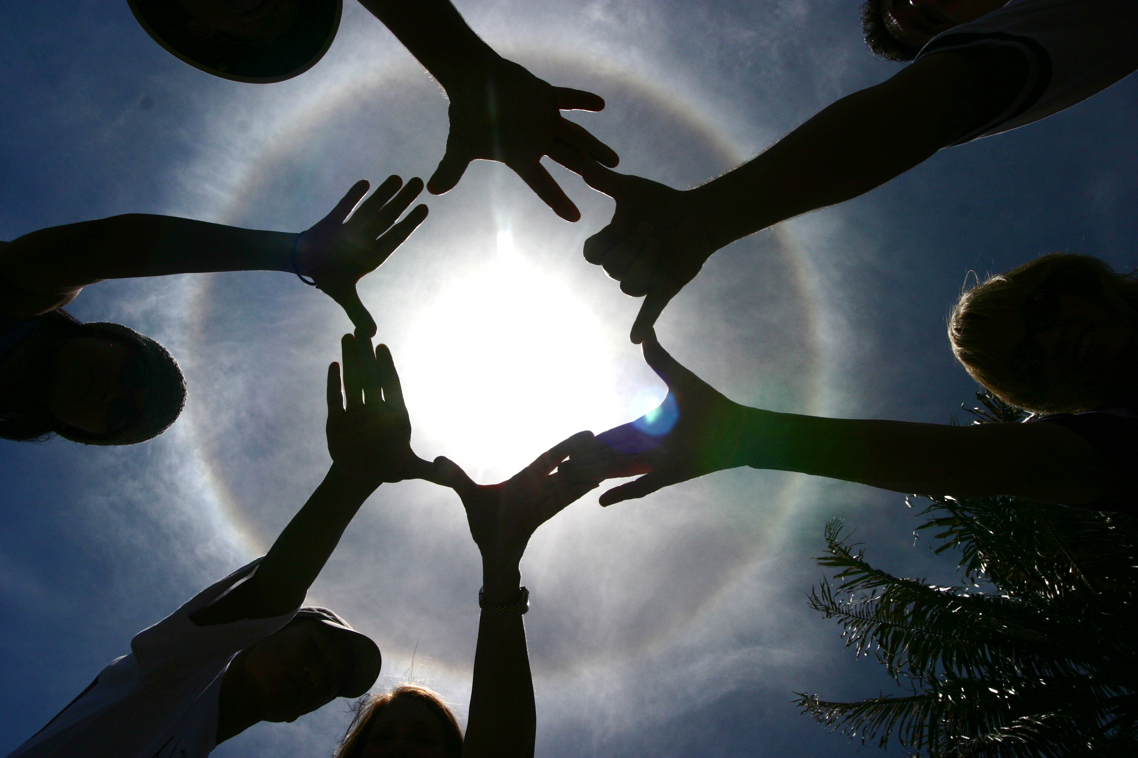

Conference programme – provisional (as at 20 Sept)
Conference language: English
TBC = to be confirmed

Sept. 21-22: YOUTH PROGRAMME
See separate information at conf. website – (language: Norwegian)

THURSDAY SEPT 23
AFTERNOON
14.30 Pre-conference: NORDIC PEACE-COOPERATION MEETING:
FN-Sambandet /UNA office, Storgata 33
For all IPB members and supporters in the Nordic region

EVENING
GRAND OPENING CEREMONY
NOBEL PEACE CENTRE, Brynjulf Bulls Plassen/opposite Rådhus

18.30 : doors open

Drinks on arrival

Music

Slide show of IPB exhibition: Making Peace (100 panels on 100 years of peacemaking)

MC: Ingeborg Breines

18.45 Welcome addresses
Welcome from Nobel Peace Center Director: Bente Erichsen

Welcome from Minister of Research and Higher Education: Tora Aasland

Welcome from Deputy Mayor of Oslo, Aud Kvalbein

Welcome from IPB President : Tomas Magnusson

Message from Women's International League for Peace and Freedom: President of WILPF Norway, Dagmar Karin Sørbø

19.10 Keynote address: ‘A Climate of Peace’ - Federico Mayor,
former UNESCO Director-General, Foundation for a Culture of Peace, Madrid

19.30 Award of the 2010 Sean MacBride Peace Prize to Binalakshmi Nepram: - Tomas Magnusson, IPB President

19.40 Guided tour of the Center

20.15 Move to the House of Humanism, St. Olavs gt. 27

Acceptance speech: Binalakshmi Nepram,
Control Arms India/Manipur Women Gun Survivors’ Network

Informal gathering with food and drink

FRIDAY SEPT 24
LITERATURE HOUSE, Wergelandsveien 29

MORNING

From 8.30 – Registration

Slide show of IPB exhibition: Making Peace (100 panels on 100 years of peacemaking)

Music

9.30 – 12.30 (incl. break) DISARMAMENT FOR DEVELOPMENT
The ‘D for D’ programme is IPB’s current main work. Our focus is on the resources spent on the military, rather than on sustainable development, and also the effects of militarism on communities and the environment.

MODERATOR: Colin Archer – IPB’S WORK/MILITARY SPENDING
- Subrata Ghoshroy, M.I.T., USA: MILITARY RESEARCH
- Corazon Fabros, Philippines : MILITARY BASES
- Khder Kareem, Mayor of Halabja: WEAPONS OF MASS DESTRUCTION :The Iraqi ‘experiment’ of using chemical gas, its effects …and our desire for peace now.
- Joe Murray, AFRI, Ireland: CAMPAIGNING
- Allison Pytlak, Religions for Peace Arms Down campaign : YOUTH
- Fred Lubang, IANSA-ICBL-Nonviolence Intl : DISARMAMENT AND THE CHALLENGES 'FOR DEVELOPMENT'

LUNCH
AFTERNOON
14.00 – 16.00 NUCLEAR DISARMAMENT
For decades IPB has been working to promote the elimination of nuclear arsenals. Current efforts focus on the struggle to secure support from governments for a nuclear weapons convention.

MODERATOR: Stine Rodmyr, Nei til Atomwåpen, Norway
- Hiroshi Taka, Gensuikyo + Terumi Tanaka, Hidankyo: NPT ACTIONS with video
- Peter Weiss, IALANA : LEGAL PERSPECTIVES
- Carlos Vargas, Costa Rica: SOUTHERN VIEW
- Alyn Ware, PNND: WORK OF PARLIAMENTARIANS

16.30 – 18.00
Hot spot debate:
NORWAY AS A PEACE NATION

In Norway we have a strong tradition of believing that we are a peace nation. Which arguments support this belief? Digging deeper, what findings contradict this belief -- and how do we deal with these contradictions?

MODERATOR: Tarja Cronberg, Chair, Finnish Peace Union
- Øyvind Tønnesson, Lillehammer University College
- Alexander Harang, Norwegian Peace Association
- Ingrid Eide, politician, researcher, Norway.

EVENING
18.30 – 20.00

Special panel:
HISTORY: 100 YEARS...(AND MORE) OF PEACEMAKING
IPB is unique as an international peace organisation in having a history that goes back to the early 1890s. As such there is a tremendous variety of campaigns and experiences on which it can draw. The panel will look at several quite different traditions/debates.

MODERATOR : Bruce Kent, UK – former IPB President
- Metta Spencer, Editor, Peace Magazine, Canada. Author: The Russian Quest for Peace and Democracy
- Fredrik Heffermehl, Author: What Nobel Really Wanted, Norway
- Yeshua Moser-Puangsuwan, Nonviolence International, Ed./Author Nonviolent Intervention Across Borders
- Peter van den Dungen, Bradford University, Dept of Peace Studies + International Network of Peace Museums. Remembering & Celebrating Peace: Peace anniversaries and museums as tools of peace culture.

SATURDAY SEPT 25
LITERATURE HOUSE, Wergelandsveien 29

MORNING
9.30 – 11.00 Panel: Women and peace – UNSC Resolution 1325*
Courageous and creative individual women and women's groups have over the centuries searched for alternatives to war, often with meagre means. All 4 UN world conferences on women have approached this issue in a comprehensive manner, emphasizing "equality, development and peace" as interdependent entities. From the Beijing conference in 1995 and onwards, a gender perspective has been more and more important. Ten years ago, on October 30, 2000, the Security Council unanimously adopted a resolution inspired by women from civil society and UN agencies. The resolution calls for 3 P's: Participation of women at all levels of governance and especially at peace making tables, Prevention of violence and Protection of women during violence. This resolution was followed by the subsequent resolutions 1820 (2008), 1888 (2009) and 1889 (2009). Much remains to be done both as to interpretation and implementation of the resolutions. *Downloadable from www.peacewomen.org

MODERATOR: Cora Weiss - IPB UN representative/Past President
- Madeleine Rees, Secretary-General, WILPF: UNSC Resol. 1325: myths and realities
- Betsy Kawamura. Member of WILPF Norway. Survivors of gender based violence
- Eva Quistorp, Co-founder of Women for Peace, Germany, + global women’s coalition on climate justice: From the European women for peace marches against nuclear weapons to Beijing 1995 and Resolution 1325 implementation in Africa, Asia and the Balkans.
- Binalakshmi Nepram, Manipur Women Gun Survivors’ Network

11.30 – 12.30 WORKSHOPS (3 sessions only)

1. Campaigning on NATO
Reiner Braun, Germany, IPB Board member
Arielle Denis, Mouvement de la paix, France

2. African peacemaking
Rev. Prosper Rudakurwa, DRC/Rwanda

3. Peace music
Tony Kempster, Movement for the Abolition of War, UK, IPB-Vice-President (guitar)
Sue Gilmurray, Chair, Movement for the Abolition of War, UK (keyboards)

LUNCH

AFTERNOON
14.00 – 15.30
Hot spot debate:
THE WEST’S ROLE IN AFGHANISTAN: EXIT STRATEGIES
On October 7th nine years will have passed since the invasion of Afghanistan. What has been accomplished so far? What mistakes have been made? Many countries are currently starting their withdrawal from Afghanistan. What exit-strategy seems most feasible?

MODERATOR: Ingeborg Breines, IPB Vice-President
- Kristian Harpviken, Director, Oslo Peace Research Institute, PRIO
- Homa Poyan (Afghanistan), Nansen Peace Center
- Arielle Denis, Mouvement de la Paix, France

16.00 – 17.30
PEACE EDUCATION
Already in the early years of IPB’s life the issue of peace education was crucial. In recent decades too it has been a key focus of peace activism and reflection. Among the current challenges is the question of how to integrate a peace education dimension into the Disarmament for Development programme launched by IPB.

MODERATOR: Alicia Cabezudo, Argentina (IPB Board member, convenor of IPB Peace education working group)
- Cora Weiss, New York – NO PEACE WITHOUT PEACE EDUCATION
- Verdiana Grossi, Univ. of Geneva – HISTORY OF PEACE EDUCATION
- Catherine Roberts - Imperial War Museum North, UK: BUILD THE TRUCE LEARNING INITIATIVE

EVENING
18.00 – 19.00
CONCLUDING PLENARY

MODERATORS: Erik Strom (President Norges Fredsrad) & Tomas Magnusson (President, IPB)

- Reports from workshops

- Input from youth programme

- Centenary messages received from around the world

- Conference Declaration - discussion

- Concluding remarks

BREAK FOR SUPPER

Move to Blå music club, Brenneriveien 9c.
20.30 CONCERT: Bugge Wesseltoft / Anders Engen / Paolo Vinacci / Nils Bech / Bendik Giske….
http://www.blaaoslo.no/program

SUNDAY SEPT 26
NOBEL INSTITUTE, Henrik Ibsens gate 51 (NOTE ADDRESS CHANGE) -- ALL WELCOME

MORNING
9.30 Anne Kjelling, Nobel Institute – brief welcome

9.40 – 11.00 IPB ASSEMBLY (elections etc)

11.00 cutting the cake ! + coffee

11.30 – 12.30 : 21st Century Peace Climates: A panel discussion with former IPB Presidents
MODERATOR: Tomas Magnusson
- Bruce Kent
- Maj-Britt Theorin
- Cora Weiss

LUNCH

AFTERNOON
14.00 – 17.00 IPB COUNCIL (all other business)
(followed by short meeting of newly-elected Board)

