***P R O G R A M M E***

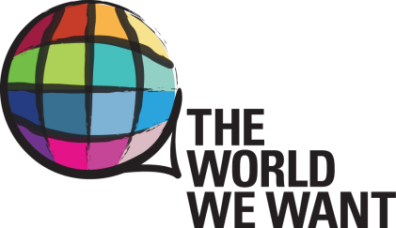

**P E O P L E S ’ V O I C E S**

***“Women and the Post-2015 Agenda”***

**When:** March 7, 2014, 1:15 – 2:45pm

**Where:** UN Headquarters, Conference Room 3

**Webcast:**  <http://www.worldwewant2015.org/PeoplesVoices>

**Interact Live on Twitter via @worldwewant2015 and #VOICES2015**

The [World We Want Platform](http://www.worldwewant2015.org/) will host the seventh interactive session of its *Peoples’ Voices Series*. The theme for this month's event will be ***Women and the Post-2015 Agenda*** which will coincide with the PGA’S High Level event on “Women, the Young and Civil Society” on March 6 -7, 2014. Representatives of Member-States, non-governmental and civil society organizations, women’s and girls’ organizations, social movements, youth-led organizations, UN agencies, media, academia and others are invited to attend.

Hosted by The World We Want *Policy and Strategy Group* (comprised of members from Civil Society and the United Nations), and co-sponsored by the Feminist Task Force this "Peoples’ Voices" Series event will have discussants explore how gender equality and women’s and girls’ issues can feature prominently in the next development agenda, making the connections with the High Level Event of the President of the General Assembly on the Contributions of Women, the Young and Civil Society to the Post 2015 Development Agenda, as well as International Women’s Day “Equality for women is progress for all,” and the upcoming Commission on the Status of Women (CSW) on March 10 – 21, 2014 . The session will feature how women’s voices are reflected in the global discussions on Post 2015 and how women are making their voices heard on the ground and online.

The “Peoples’ Voices” Series is an opportunity for people to showcase various points of view and ideas for global development around important themes and topics. Sessions are supplemented by an overview of how the [World We Want](http://www.worldwewant2015.org/) platform hosts Post 2015 consultations and how it functions as a tool that facilitates improved communications, transparency and accountability around the Post 2015 global development agenda.

**AGENDA**

* Opening - **Rosa Lizarde**, Co-Chair PSG, World We Want 2015; Global Director, Feminist Task Force
* Introduction by Moderator **Pamela Falk, CBS News, UN Resident Correspondent** (invited)
* Panel Discussion “Women and Girls and the Post-2015 Development Agenda”
  + **Nebila Abdulmelik,** African Women’s Development and Communications Network (FEMNET), Kenya
  + **Marta Benavides,** Siglo XXIII/Feminist Task Force/Global Call to Action against Poverty, El Salvador(ageing community)
  + **Lori Johnston,** Yamasi People, (indigenous peoples)
  + **LGBTQI/SOGI** Communities Speaker
  + **Vandana Chaudhry,** Ph.D. Assistant Professor, City University of New York (disabilities)
  + **Abigail E. Ruane,** Ph.D. PeaceWomen Program Manager, Women's International League for Peace and Freedom (women, peace and security issue app)
  + **Corinne Woods**, Director, UNMC, Reflections on MyWorld “Gender Equality report” (invited)
* Question and Answer Session (including questions received via Twitter, use #voices2015)
* Closing Remarks from the Panel
* Conclusion, Moderator